Sign Out Button

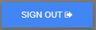

The Sign Out button is located on the far left of the Toolbar. Click this button to log off the desktop. You will then be returned to the Login Page.

